Twangilizer User Manual

## Description:

The Twangilizer is a Eurorack module that fits in a 3U x 20HP format. It is an “additive synthesis” module that generates four sine waves that are harmonically related to a given input signal.

Using the 8-position rotary switches the user can select from 8 harmonics (1f – 8f). The resulting signals can be used as-is or can be halved in frequency by the toggle switches. This gives the user many interesting options when creating a sound.

The levels of the resulting harmonics are set by VCAs that are controlled by the front panel potentiometers and the CV inputs. An indicator LED displays the level of the adjustment.

## Inputs:

1. Clock input. Accepts signals > .25Vpp. 20 – 20KHz.
2. CV1 – CV4. Control the level of the harmonics sent to analog out. 0-8V range.

## Outputs:

1. Analog Out. Sum of all four harmonics.
2. CLK Outputs 1-4. Digital outputs of the four harmonics. For syncing other modules.

## Controls:

1. Four Harmonic Selectors – Select from 1f through 8f.
2. Four Harmonic divide-by-two selectors – Select f/1 or f/2
3. Four CV Bias controls – Controls initial level of each harmonic.

## Indicators:

1. Clock Present Indicator – Glows Green when a Clock signal is present.
2. Four CV level indicators. – Red LED intensity shows CV level.

## Uses:

1. Use a VCO and the CV bias settings to create unique timbre profiles.
2. Use a VCO and a triggered multiple envelope generator connected to the CV inputs to create dynamically changing timbre profiles.
3. Use a VCO to create a multiple clock generator at the Digital Outputs.
4. Use multiple Twangilizers in various topologies employing the above techniques to create ultra-complex timbre profiles and different clock frequencies.

# CV Curves

The 3 graphs below show the output level of the VCAs in volts peak-to-peak vs. the CV Input voltage at various CV Bias settings.

Figure 1 CV Bias at 0%

Figure 2 CV Bias at 50%

Figure 3 CV Bias at 100%

## Front Panel:

(actual panel will differ slightly)

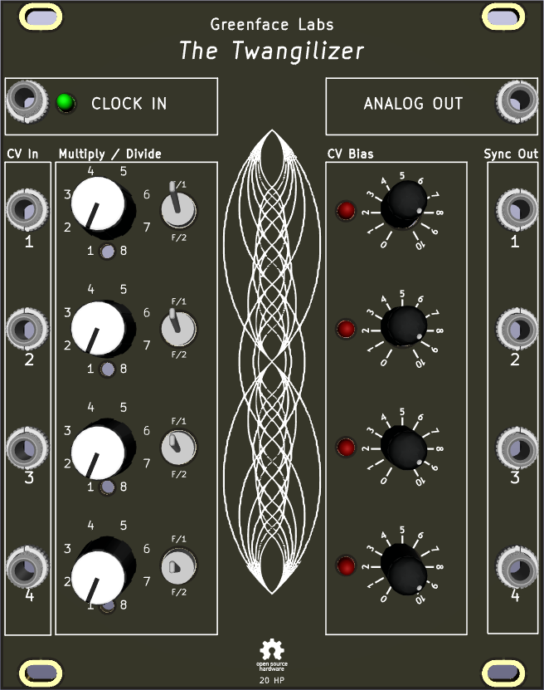

## Notes:

1. The Greenface Labs Bonkulator is the ideal multiple envelope generator. Having 8 triggered outputs, it can devote 4 to the Twangilizer and another 4 to other modules.
2. Because the Twangilizer uses phase locked loops, a portamento effect is normal.
3. All inputs and outputs are protected against ESD and over-voltage. (+/-25V continuous, protection diodes have PN Junction Guard Ring for Transient and ESD Protection).